This retrospective study is on analysing the difference in the quality of data affected by the visual aids used by students. There are two type of data recorded in the experiment.

1. Whether a student wear visual aid or not (Qualitative)
2. Quality score of each student (Quantitative , Scale)

Since the experiment are carried out with a same set of students this can be considered as depended or paired data.

Sample size of this experiment is 17.

In the first section of the analysis Boxplot views of students belongs to two groups is presented, in the second section descriptive statistics of the analysis is presented

**Boxplot**

ñ 3 marks for each graph presented;

ñ 4 marks for a correct comment/observation on each graph;

ñ 4 marks for a correct comment/observation on the comparison between measurements.

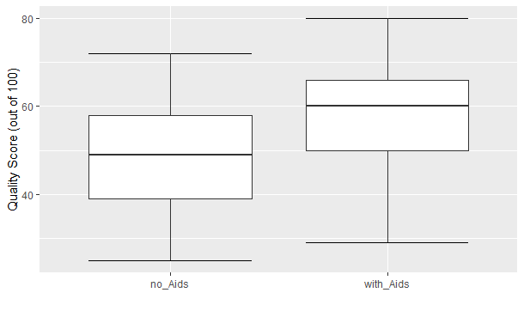

The boxplot of no visual aids is symmetrical at glance which suggest that it’s normally distributed. The mean of the students with visual aids is a value close to 60.

The boxplot of the student with visual aid is shifted towards up than the box plot of student with no visual aids suggesting that there’s an improvement of the score when wearing visual aids.

**Descriptive Statistics**

|  |  |  |
| --- | --- | --- |
| **type** | **Without visual aids** | **With visual aids** |
| Sample size | "17" | "17" |
| Mean | "46.941" | "57.647" |
| Median | "49" | "60" |
| Min | 25 | 29 |
| Max | 72 | 80 |
| Skewness | "-0.081" | "-0.463" |
| Normally distributed | "Yes" | "Yes" |

Shapiro Wilk test suggest that both the distributions are normally distributed. (Skewness, mean and median supports that claim)

Since the samples are normally distributed a best measure to describe centrality is mean and variance is the standard deviation.

In the first column we can say that mean is roughly equal to median, and in the second column it’s doubtful.

Since the both groups are normally distributed and the experiment data can be paired (dependent) the correct test to validate the claim is related T test.

**Statistical Inference**

|  |  |
| --- | --- |
|  |  |
| Mean Difference | 10.71 |
| 95% CI (Upper) | 17.86 |
| 95% CI (Lower) | 3.56 |
| p-value | 0.0059 |
| Effect Size | 0.803 |

Null Hypothesis: There’s no difference in the population mean of student use visual aids and student don’t use visual aids.

Alternate Hypothesis: A different exists between these two population means.

p-value (0.0059) < level of significance (0.05)

So we can reject the null hypothesis where a probability of making a type 1 error is less than 0.05.

This suggest that a mean difference of 10.71 was found to be statistically significant. (ES: 0.803, 95% CI [3.56, 17.86]).

Based on a sample of 17 students with visual aids and same students without visual aids, we are 95% confident that the mean difference (with visual aids – without visual aids) in quality lies between [3.65, 17.86]. The interval is always positive. This suggest that wearing visual aids make student to score more always.